Game idea, “Astroleap”.
Astroleap is the general name I have given this idea.
An auto-jumper where an astronaut jumps from asteroid to asteroid. The game should be controlled by the user tapping/holding either side of the screen, as the astronaut jumps up to the end of a level (his spacecraft) whilst avoiding a myriad of different obstacles and using comets to speed himself up. Stars are awarded at the end of each level, 1 star for beating the level and three starts for beating the level quickly without taking damage. Each planet in the solar system will have a select few of differently.
Below is a general controls scheme based on this mobile game idea.

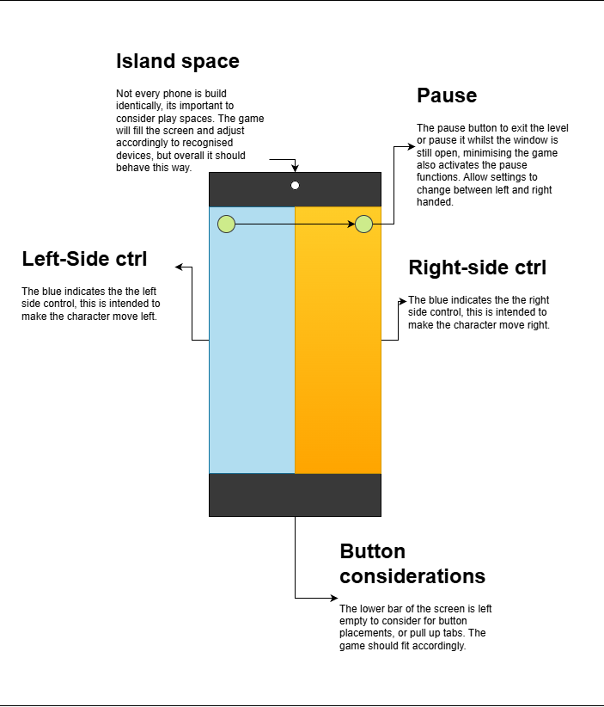

The game is intended to be an android game for general audiences, hence its simple, accessible control scheme and premise. The game is mainly intended to be played in portrait mode, as it is not a competitor for landscape gaming applications. It’s intended to be something the user plays quickly when they are bored, waiting, or in the bathroom.

